Chocolate Agar
It is a non selective, enriched growth medium used for isolation of pathogenic bacteria.It is a variant of the blood agar plate, containing red blood cells that are lysed by slowly heating to 80°C. Chocolate agar is used for growing fastidious respiratory bacteria, such as Haemophilus influenzae and Neisseria meningitidis. The agar is named for its color and contains no chocolate products.
Chocolate Agar (CAP) is the lysed blood agar. The name is itself derived from the fact that red blood cell (RBC) lysis gives the medium a chocolate-brown color. Chocolate agar is used for the isolation of fastidious organisms, such as Haemophilus influenzae, when incubated at 35-37°C in a 5% CO2 atmosphere.
The composition of chocolate agar and the Blood Agar is the same and the only difference is while preparing chocolate agar, the red blood cells are lysed.
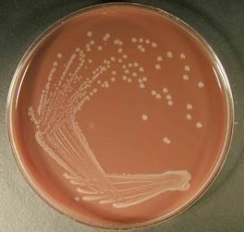Haemophilus influenzae on chocolate agar
The lysis of RBC during the heating process releases intracellular coenzyme Nicotinamide adenine dinucleotide (NAD or V Factor) into the agar for utilization by fastidious bacteria (the heating process also inactivates growth inhibitors). Hemin (factor X) is available blood cells.
The most common species that require this enriched medium for growth include Neisseria gonorrhoeae, Neisseria meningitidis and Haemophilus spp. Neither of these species is able to grow on sheep blood agar.
Chocolate agar slants is used for the short-term storage of pathogens such as N.meningitidis, S.pneumoniae, and H.influenzae for up to 1 week.
Preparation of Chocolate Agar:
- Heat-lyse a volume of horse or sheep blood that is 5% of the total volume of media being prepared very slowly to 56°C in a water bath.
- Dispense 20 ml Petri dishes. Allow the media to solidify and dry.
- Place the plates in sterile plastic bags and store at 4ºC until use.
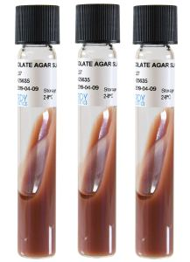Chocolate agar slants

Chocolate agar slants:
- Dispense 4 mL of the medium into 16X125 mm screw-cap tubes
- Kep the tubes in slanted position and let them solidify
Chocolate agar slants appear brown to brownish-red color. They should be stored at 4°C when not in use and warmed to room temperature (25°C) before use.
Passing result:
- N. meningitidis and H. influenzae should appear as large, round, smooth, convex, colorless-to grey, opaque colonies on the chocolate agar plate with no discoloration of the medium.
- S. pneumoniae should appear as small grey to green colonies with a zone of alpha-hemolysis (only slightly green) on the chocolate agar plate

Colony characteristics in chocolate agar
- Neisseria meningitidis: Growth on chocolate agar is greyish, non-hemolytic, round, convex, smooth, moist, glistening colonies with a clearly defined edge.
- Neisseria gonorrhoeae: Colonies on Chocolate agar are pinkish-brown and translucent, exhibit smooth consistency and defined margins, and are typically 0.5-1 mm in diameter.
- Haemophilus influenzae: Non-hemolytic, opaque cream-to-grey colonies (accompanying Sheep blood agar shows no growth)

Modification of Chocolate Agar:
- Thayer-Martin agar: It is used for the selective isolation of N. gonorrhoeae and N. meningitidis. Thayer-Martin Media is a chocolate agar supplemented with vancomycin, nystatin and colistin to inhibit the normal flora, including nonpathogenic Neisseria.
- Chocolate Agar with bacitracin: CAP with bacitracin is a selective medium used to improve the primary isolation of H. influenzae from specimens containing a mixed flora of bacteria and/or fungi.
Blood Agar
Blood Agar is used to grow a wide range of pathogens particularly those that are more difficult to grow such as Haemophilus influenzae, Streptococcus pneumoniae and Neisseria species. It is also required to detect and differentiate haemolytic bacteria, especially Streptococcus species. It is also a differential media in allowing the detection of hemolysis.
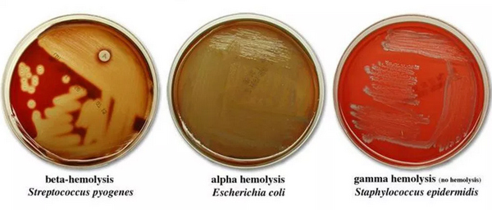

Composition of Blood Agar
- 0.5% Peptone
- 0.3% beef extract/yeast extract
- 1.5% agar
- 0.5% NaCl
- Distilled water (Nutrient Agar)
- 5% Sheep Blood
- pH should be from 7.2 to 7.6 (7.4)

Preparation of Blood Agar
- Suspend 28 g of nutrient agar powder in 1 litre of distilled water.
- Heat this mixture while stirring to fully dissolve all components.
- Autoclave the dissolved mixture at 121 degrees Celsius for 15 minutes.
- After autoclaved, allow it to cool but not solidify.
- When the agar has cooled to 45-50 °C, Add 5% (vol/vol) sterile defibrinated blood and mix gently but well.
- Avoid Air bubbles.
- Dispense into sterile plates while liquid.

Uses of Blood Agar
- Blood Agar is a general purpose enriched medium often used to grow fastidious organisms
- To differentiate bacteria based on their hemolytic properties (β-hemolysis, α-hemolysis and γ-hemolysis (or non-hemolytic)).
MacConkey agar
MacConkey agar is a selective and differential media used for the isolation and differentiation of gram-negative rods, particularly members of the family Enterobacteriaceae and the genus Pseudomonas.

Composition of MacConkey Agar
Ingredients | Amount
Peptone (Pancreatic digest of gelatin) | 17 gm
Proteose peptone (meat and casein) | 3 gm
Lactose monohydrate | 10 gm
Bile salts | 1.5 gm
Sodium chloride | 5 gm
Neutral red | 0.03 gm
Crystal Violet | 0.001 g
Agar | 13.5 gm
Distilled Water | Add to make 1 Lit
Final pH 7.1
MacConkey agar is used for the isolation of gram-negative enteric bacteria and the differentiation of lactose fermenting bacteria from lactose non-fermenting gram-negative bacteria. Pancreatic digest of gelatin and peptones (meat and casein) provide the essential nutrients, vitamins and nitrogenous factors required for growth of microorganisms. Lactose monohydrate is the fermentable source of carbohydrate. crystal violet and bile salts, which are inhibitory to most species of gram-positive bacteria. Sodium chloride maintains the osmotic balance in the medium. Neutral red is a pH indicator that turns red at a pH below 6.8 and is colorless at any pH greater than 6.8. Agar is the solidifying agent.

Uses of MacConkey Agar
- MacConkey agar is used for the isolation of gram-negative enteric bacteria.
- It is used in the differentiation of lactose fermenting from lactose non-fermenting gram-negative bacteria.
- It is used for the isolation of coliforms and intestinal pathogens in water, dairy products and biological specimens.

Preparation of MacConkey Agar
- Suspend 49.53 grams of dehydrated medium in 1000 ml distilled water.
- Heat to boiling to dissolve the medium completely.
- Sterilize by autoclaving at 15 lbs pressure (121°C) for 15 minutes.
- Cool to 45-50°C.
- Mix well before pouring into sterile Petri plates.

Result on MacConkey Agar
Lactose fermenting bacteria grow as red or pink .The red colour is due to production of acid from lactose and non lactose fermenting bacteria white in colour.
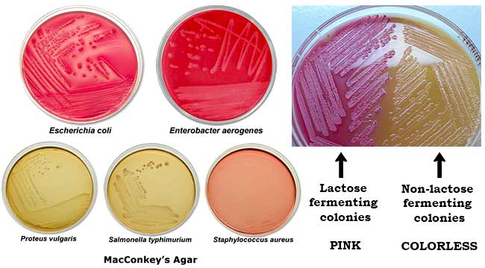

Lowenstein-Jensen (LJ) Medium- Composition, Principle, Uses, Preparation:
Lowenstein-Jensen (LJ) is the selective medium which is used for the cultivation and isolation of Mycobacterium species. It was developed by Lowenstein who incorporated congo red and malachite green to inhibit unwanted bacteria. The present formulation, a glycerated egg-based medium, is based upon Jensen’s modification. Jensen’s version eliminates congo red and uses a moderate concentration of malachite green to prevent growth of the majority of contaminants.

Composition of LJ Medium
Ingredients | Amount
Potato Flour (Potato Starch) | 30.0 gm
L-Asparagine | 3.6 gm
Monopotassium Phosphate | 2.4 gm
Magnesium Citrate | 0.6 gm
Malachite Green | 0.4 gm
Magnesium Sulfate | 0.24 gm
Glycerol | 12 ml
Egg suspension | 1000 ml
Distilled Water | 600 ml

Principle of LJ Medium
L-Asparagine and Potato Flour are sources of nitrogen and vitamins. Monopotassium Phosphate and Magnesium Sulfate enhance organism growth and act as buffers. Malachite green, prevent the growth of the majority of contaminants and encouraging the growth of Mycobacteria. Egg Suspension provide fatty acids and protein required for the metabolism of mycobacteria. When heated, the egg albumin coagulates, thus providing a solid surface for inoculation. Glycerol serves as a carbon source and is favorable to the growth of tubercle bacillus.

Uses of LJ Medium
- It is used for the diagnosis of Mycobacterial infections.
- It is used for testing antibiotic susceptibility of isolates.
- It is also used for differentiating different species of mycobacterium Preparation of LJ Medium
- Dissolve 37.3 gm of the medium in 600 ml of distilled water containing 12 ml of glycerol.
- Heat if necessary to dissolve the medium completely.
- Autoclave at 121°C for 15 minutes.
- Prepare 1000 ml of a uniform suspension of fresh eggs under aseptic conditions.
- Aseptically mix the 1000 ml of egg suspension with 600 ml of the sterile Lowenstein-Jensen Medium cooled to 50 – 60°C, avoiding air bubbles.
- Dispense the finished medium into sterile screw-cap test tubes.
- Place the tubes in a slanted position and heat at 85°C for 45 minutes.

Colony Morphology on LJ Medium
Cultures should be read within 5 to 7 days after inoculation and once a week thereafter for up to 8 weeks.
